Group Engagement Coding Manual
Contents
OVERVIEW 1
COLUMNS 2
ID 2
<id>,<group>,<tdate>, <bdate>,<sex> 2
ONSET 2
OFFSET 2
CONTENTS (ARGUMENTS) OF ID VARIABLE 2
<id> 2
<group> 2
<tdate> 3
<bdate> 3
<sex> 3
TASK 3
<model_type>, <correct_final_ci> 3
ONSET: 3
OFFSET: 3
<model_type> 3
<correct_final_ci> 6
ACTIVITY 6
ONSET: 6
OFFSET: 6
<activity_yn> 6
ENGAGEMENT TYPE 6
ONSET: 7
OFFSET: 7
<looking_yn> 7
<touching_yn> 7
<solving_yn> 7
<teacher_yn> 7

OVERVIEW

This study explores differences in engagement during a collaborative Duplo building task conducted in schools.
Four participants are shown one of four schemas of the same construction from its four sides (example below) and must build the construction. Participants complete up to 8 models all together.
Each video we code will be for a single individual. The video will consist of three videos: an aerial view of the group building, a view of the specific child, and the exported eye-tracking video of that child’s view. Our aim is to understand the different ways in which the children are engaging with the task.
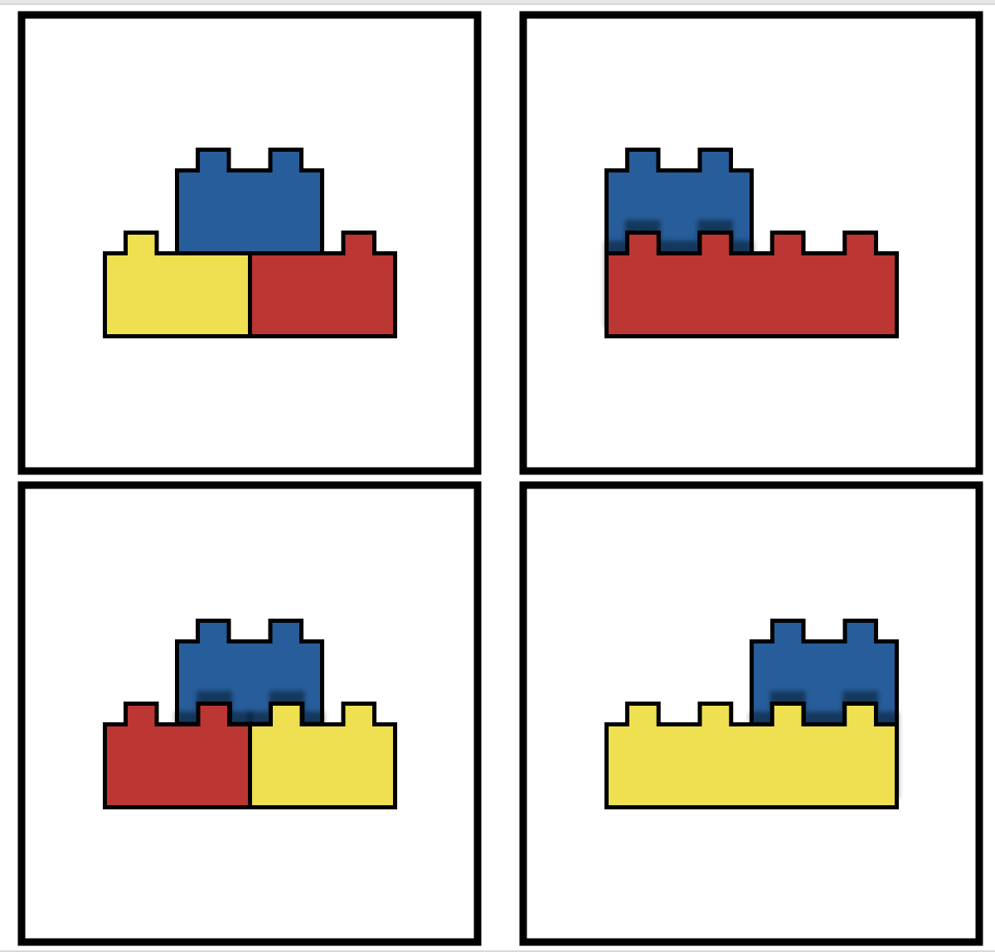

COLUMNS

ID
This column provides meta-data about the video that is being coded and which participant. It is really important because it’s being printed along with the other data and it allows us to know which participant was coded. Otherwise – we would not know. Please make sure there is only one cell in the video and it covers ALL the video.

<id>,<group>,<tdate>, <bdate>,<sex>

ONSET
First frame of video

OFFSET
Last frame of video (don’t change)

CONTENTS (ARGUMENTS) OF ID VARIABLE
Get information from coversheets or questionnaires
Any missing data should be recorded as “.”

<id>
Participant ID is written in as BT_S#XX_CG where:
XX is the participant number For numbers less than 10, should appear with a starting 0. So participant 1 is “01”.

<group>
Participant group is written as AX, where A == school code, X == group code. E.g. A1

<tdate>
Subject’s test date
Format: mm/dd/yy

<bdate>
Subject’s date of birth.
Format: mm/dd/yy

<sex>
male ‘m’
female ‘f’

TASK
The aim of this column is to capture what trial the participant is currently doing. There are 8 trials – each corresponds to a model that the participant is asked to build. Ignore practice trials.

<model_type>, <correct_final_ci>

ONSET:

The first frame where the picture of the model appears

OFFSET:

The frame where the model starts to be taken apart OR the researcher confirms a correct build OR or subjects turning tablets around to display, whichever comes first.

<model_type>
m1 = first model – 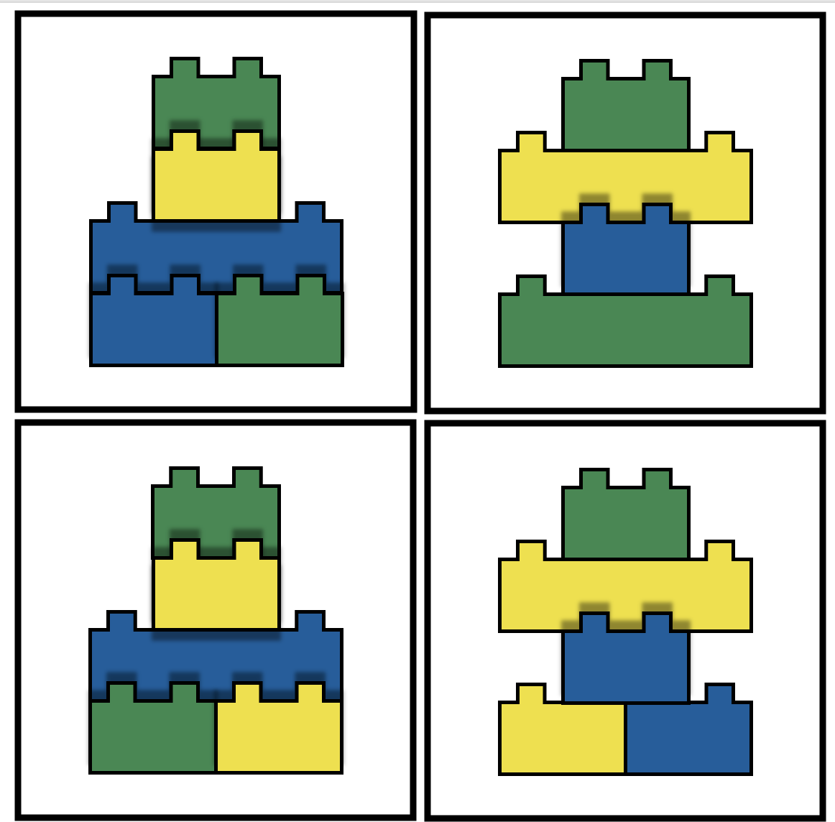
m2 = first model – 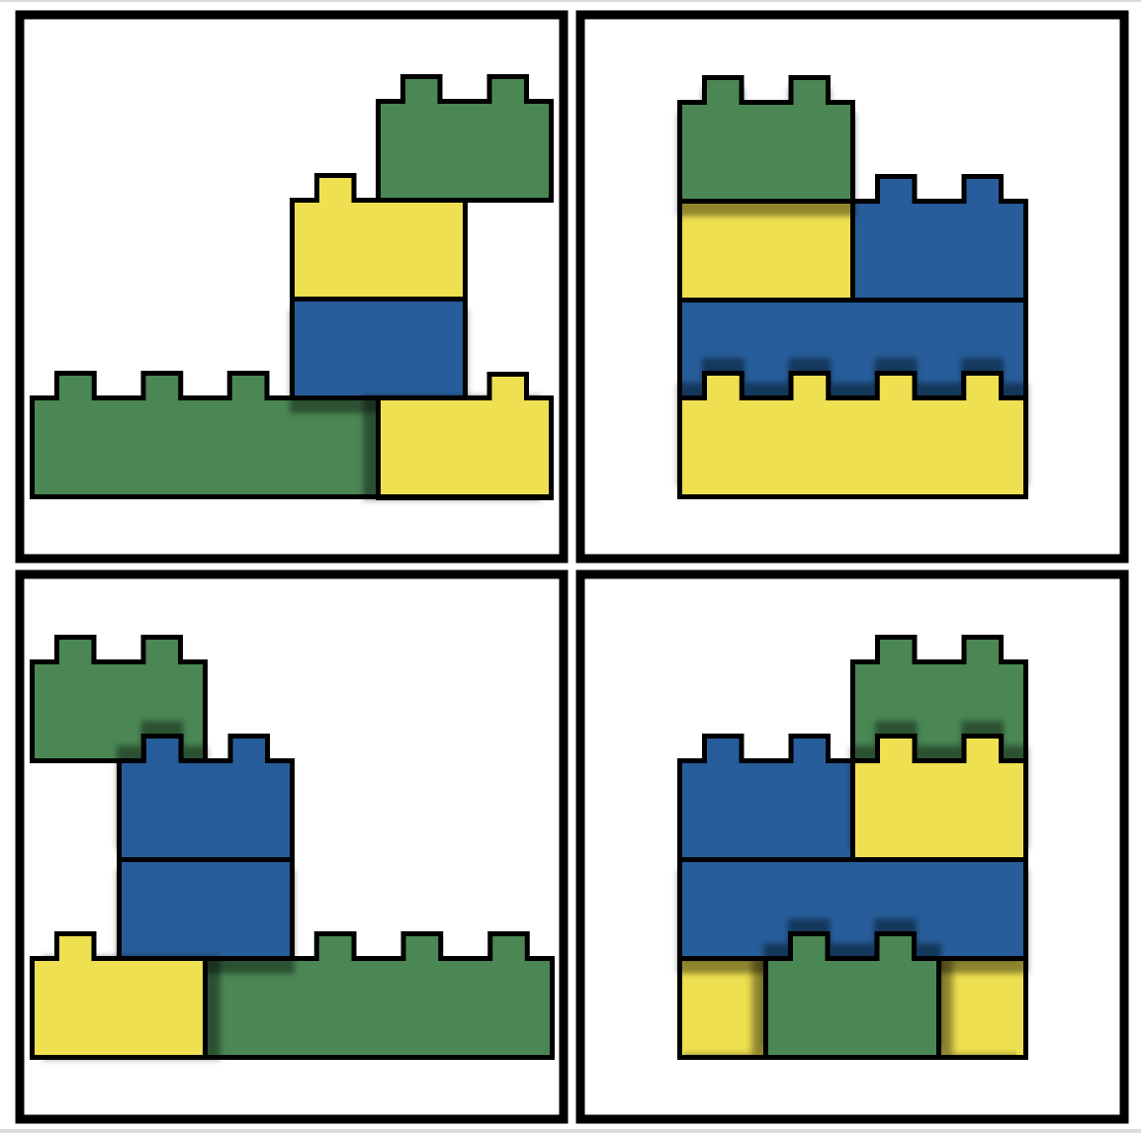
m3 = first model – 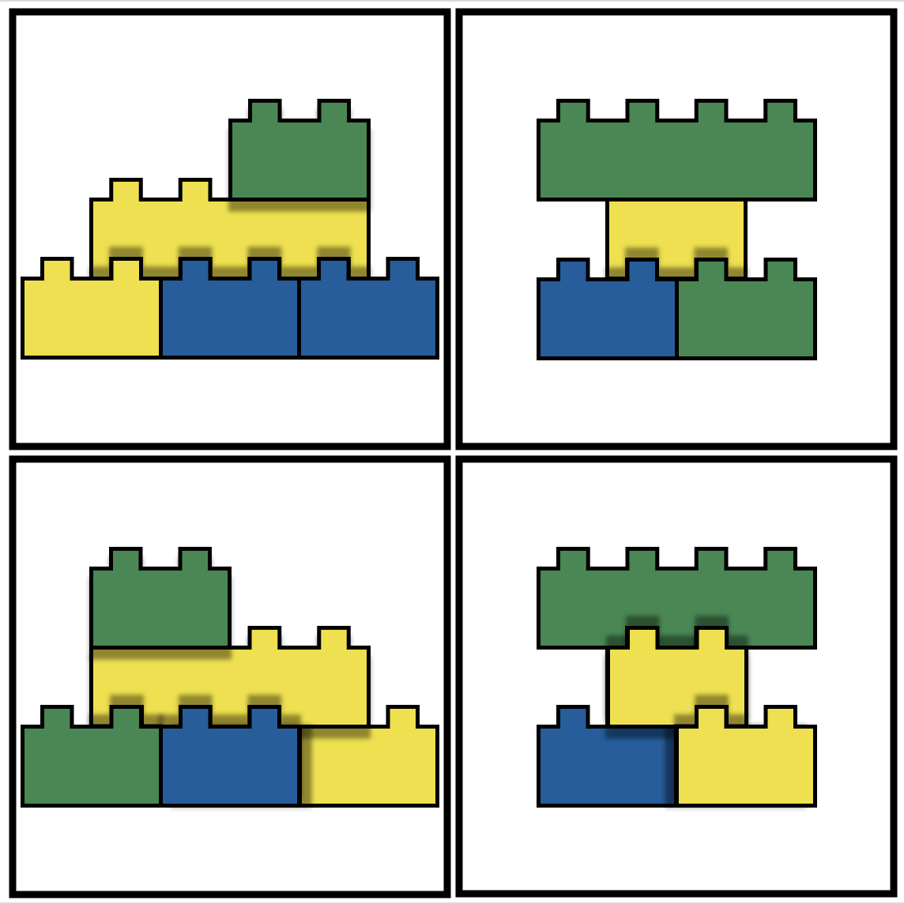
m4 = first model – 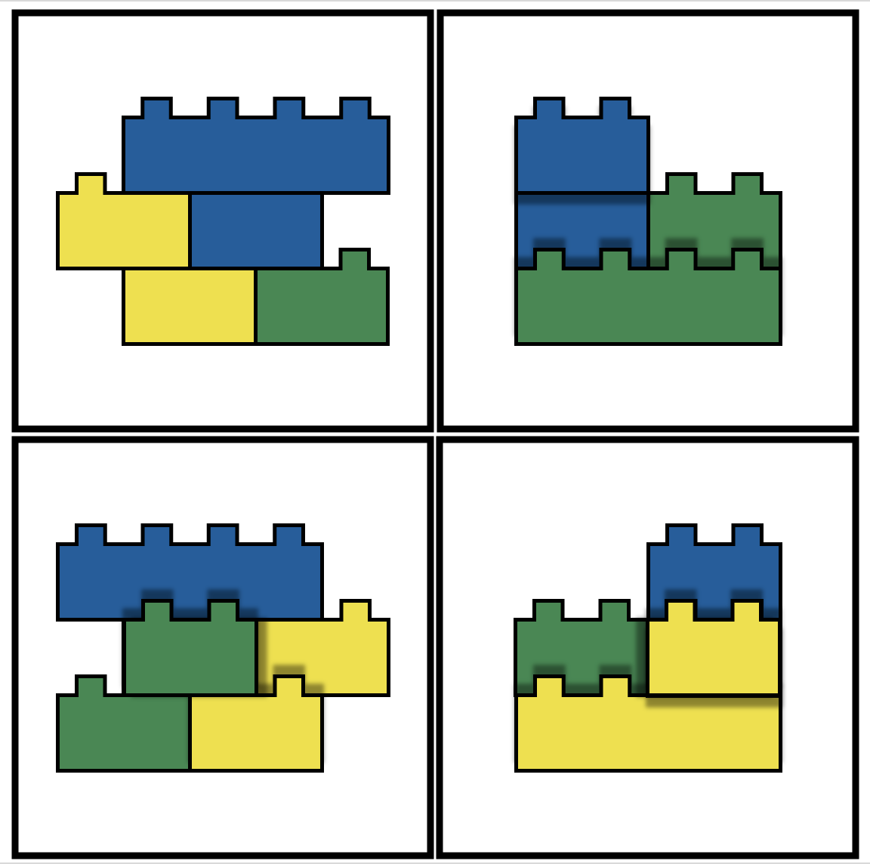
m5 = first model – 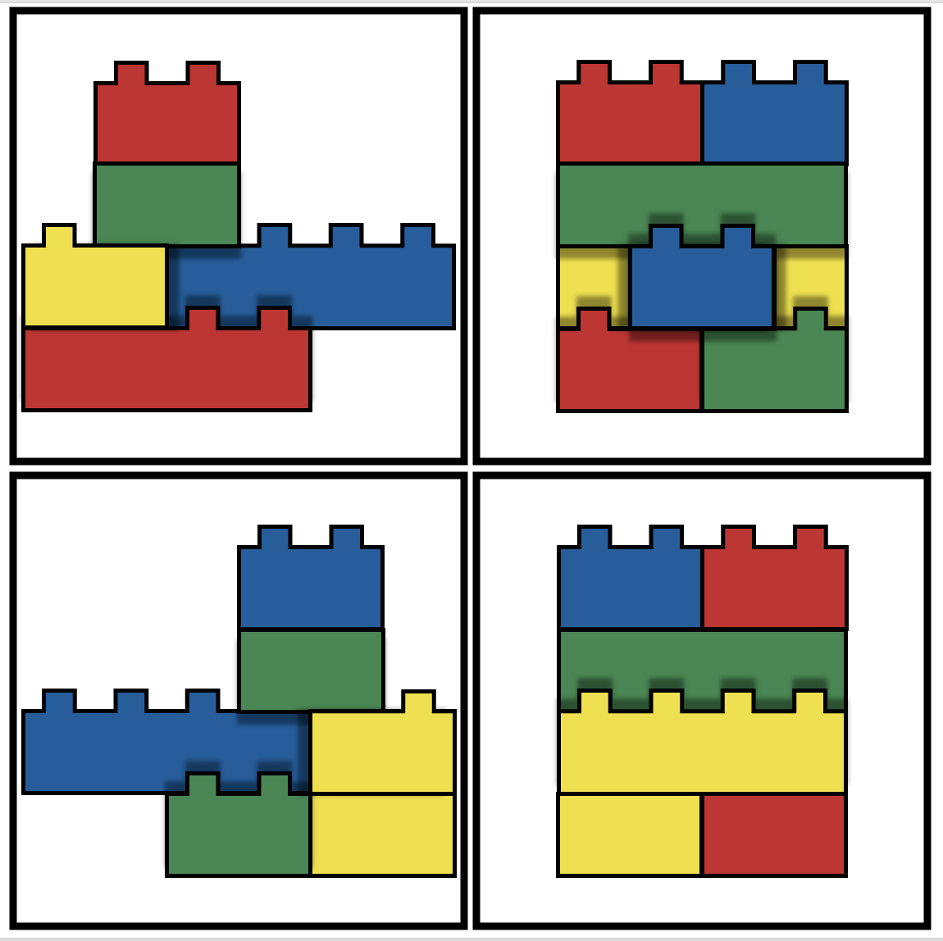
m6 = first model – 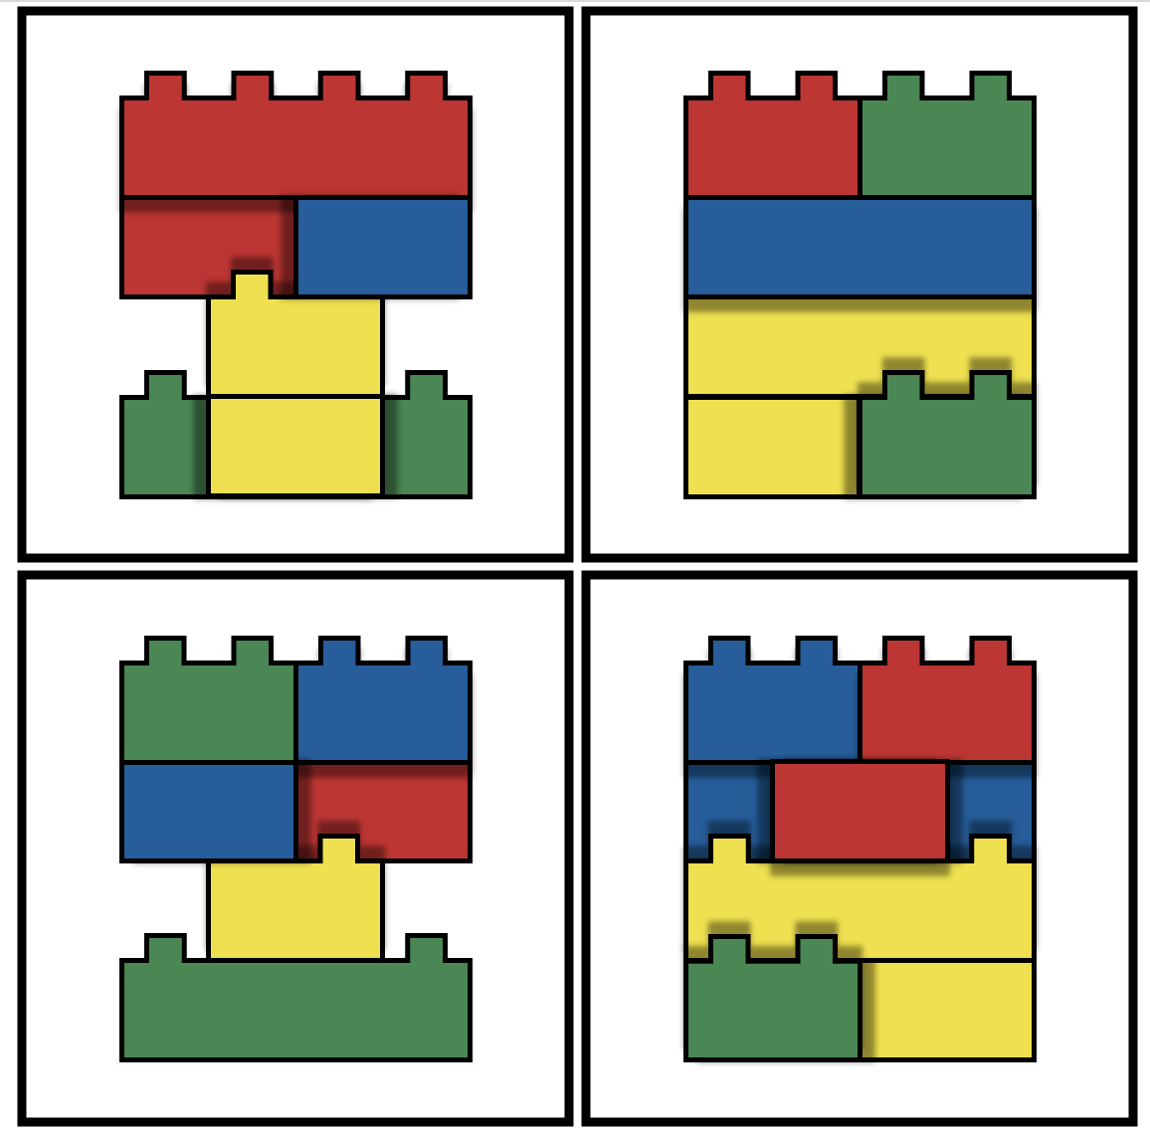
m7 = first model – 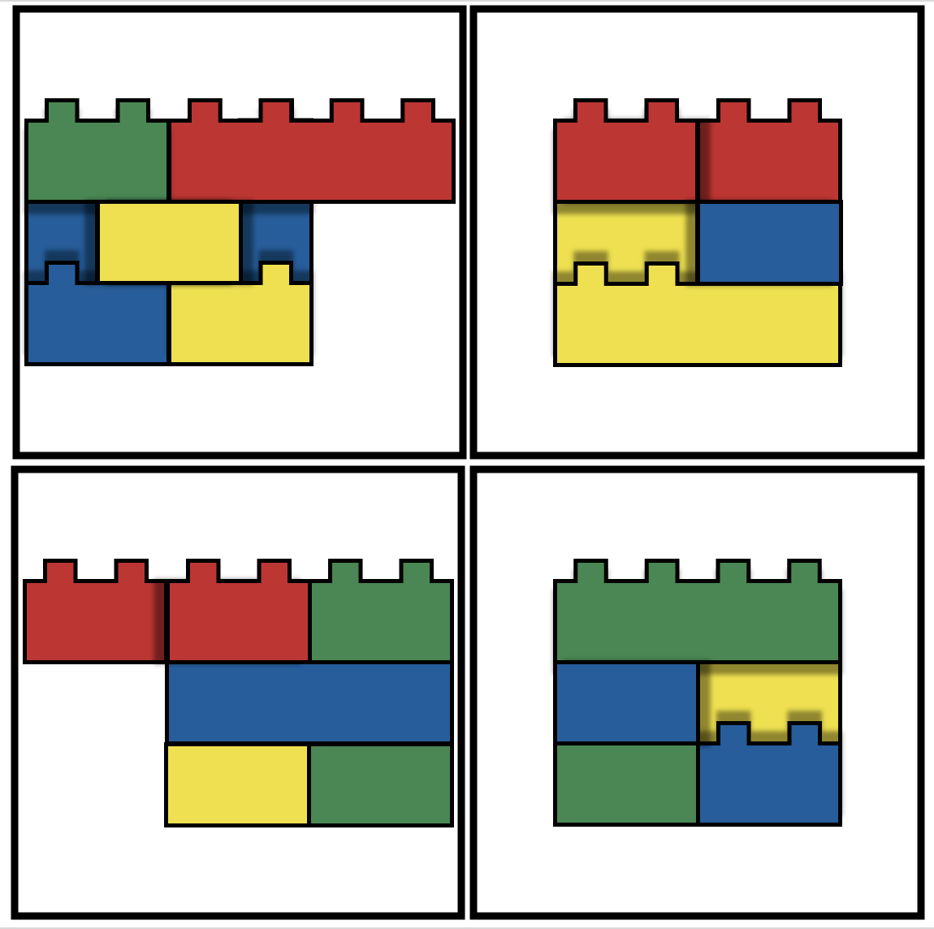
m8 = first model – 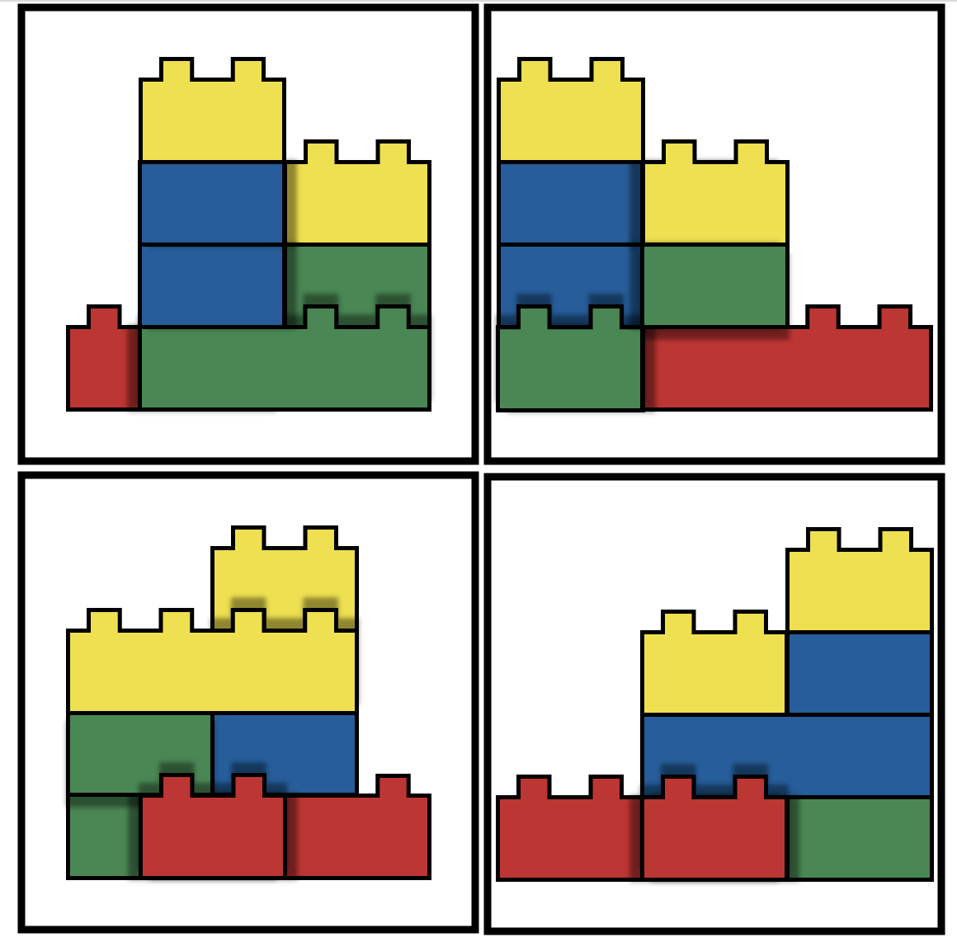

<correct_final_ci>
This code includes whether the final model the participant created was correct or incorrect. Use the pictures above, the Final constructions powerpoint and pictures, and your own DUPLO blocks, to check if the model is correct.
c = correct model
i = incorrect model

ACTIVITY
In this column, we code what task the participant are doing at each moment. This should be continuous coding (that is – one frame after the end of one cell, starts the beginning of the next cell), and the cell should reflect what is the participants’ activity

ONSET:

First frame the participant started an activity

OFFSET:

Last name the participant was in the activity

<activity_yn>
y = the participant is invested in the spatial task – can be either by looking at own group work, leading own group work, pointing at own group work, acting on the spatial task (including touching the parts, showing the parts to others, following the work of others on the task, or participating in a discussion with the teacher.
n = the participant is not taking part of the activity, including talking to other without be attentive to the task, be out of the table, and so on.

LOOKING_TIME (AREAS OF INTEREST)
In this column, we code where children are looking between several important areas of interest. This should be continuous coding (that is – one frame after the end of one cell, starts the beginning of the next cell) WITHIN the Activity cells when activity is coded as ‘Y’.

ONSET:

Can be two options:

First frame of the Activity cell with activity coded as ‘Y’ (if this is the first cell within the activity).

First frame the participant started the specific looking area.

OFFSET:

Last frame of the specific looking area OR last frame of the Activity cell with activity coded as ‘Y’

<peers>
y = the child is looking at one of their peers
n = the child is not looking at one of their peers

<blocks>
y = the child is looking at the blocks/model
n = the child is not looking at the blocks/model

<tablet>
y = the child is looking at their tablet
n = the child is not looking at their tablet

<researcher>
y = the child is looking at the researcher
n = the child is not looking at the researcher

SPEAKING
In this column, we code WHETHER the child is speaking. Note, it does not matter what they are saying. We are just coding a single cell which lasts the whole time they are speaking. If they are not speaking there should be nothing.

ONSET:

First frame the participant started speaking

OFFSET:

Last frame the participant was speaking

<speaking>
y = the child is speaking

TOUCHING
In this column, we code WHETHER the child is touching the model. Note, it does not matter what they are saying. We are just coding a single cell which lasts the whole time they are touching model/blocks. If they are not touching the blocks there should be nothing. If they are, you should indicate whether they are physically building or just demonstrating using the blocks.

ONSET:

First frame the participant started speaking

OFFSET:

Last frame the participant was speaking

<building_y>
y = the child is building with the blocks

<demonstrating_y>
y = the child is demonstrating with the blocks

